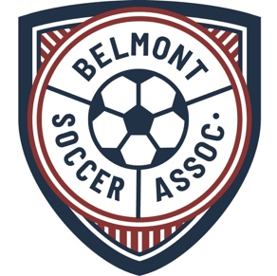

Belmont Soccer Association* Service Scholarship

Contact Information
Name
Address
Home Phone
Cell Phone
E-Mail Address

BSA Service Capacity and Duration: check all that apply

 | Freshman Year |  |  | Sophomore Year |  | Junior Year |  | Senior Year
Service Capacity | Fall | Spring |  | Fall | Spring | Fall | Spring | Fall | Spring
Coach/Asst Coach
Placement Assistant
Mentoring
Other (specify)
Other (specify)

Details of Service

The Purpose of the BSA is to develop, organize, administer, promote, and enhance the game of youth soccer on behalf of its membership, and to actively participate in or collaborate with organizations that have similar objectives. Briefly describe how your duties for items checked above met this Purpose, and ways you believe you excelled in the execution of your service. Please include number of service hours in each area of service, whether those hours were paid positions or volunteer, and the names of anyone who supervised you. (Use additional sheets if necessary).

Previous Service to Belmont Soccer Association*

If applicable, summarize any service prior to entering High School.

* Service time performed includes legacy Belmont Second Soccer organization, which was incorporated into BSA in 2019.

